**EHS risk management** is a method of identifying potential **environmental** and **safety** hazards in an organization and minimizing their impact. It's a way to predict and prepare for dangerous situations before they cause **harm** to any personnel or property. AI provides opportunities not only to individuals but also to business, society, and government. Evolving at a rapid pace, it revolutionizes every corner of every industry. The majority of **business executives cannot afford to neglect AI** and simply have to implement it if they want to be competitive over time. Modern technologies involving Artificial Intelligence are making a huge impact on **workplace safety** and efficiency. Organizations across the globe are putting serious efforts to improve their sustainability and environmental, health and safety performance along with precise data management. AI can be integrated with the current railways industry business model to improve the current working conditions and safety of the employees.

The few common types of EHS in the railways industry are

* Train / worker accidents
* Noise and vibration
* Diesel exhaust
* Fatigue
* Electrical hazards
* Electric and magnetic fields

Despite the overall improvement of the railway industry’s safety record in recent decades, the rate of train accidents has not considerably decreased, with a substantial number of accidents occurring in recent years. After an in-depth look into the railway system and its train platforms, we learned that railway safety is highly dependent on human behaviour inside and outside that specific system.

SOLUTION

We can develop customizable camera-based AI solutions to prevent accidents in the railway industry. We propose a solution that will work on two levels. The first uses AI and video analytics to detect different personal protective equipment to increase the safety of workers in the railways yard. The second ensures that no one in on the track when there are trains passing by. This is done by monitoring the movement of passengers at railway tracks and employees in railway yards and tunnels alerting the person on the track in case a specific distance is not maintained with the incoming train. The person is informed through various devices and equipment, such as lights and sound alerts.

Personal Protective Equipment (PPE) is highly diverse, affecting the reliability of detection, as different shapes and sizes of the same item can differ according to specific PPE types and situational factors. Classifying the presence or absence of certain PPEs reliably depends on two aspects: the difficulty of detecting the PPE itself, and the plausibility of classifying the detected PPE correctly. PPE that is easy to detect and has high classification plausibility includes helmets, masks, sleeves, and other PPEs with highly consistent and distinct shapes, as the perception of their shapes does not change due to different camera angles or distortion. This leads to PPE classification with higher reliability, allowing us to expand solutions to detect company specific PPE. For example, rather than detecting all types of helmets, we can distinguish between specific helmets based on their colour or shape. PPE which are harder to detect, but have high classification plausibility are safety glasses and earmuffs. The transparent colour of safety glasses makes them difficult to detect, especially at longer distances. However, once detected, it is easier to classify glasses as safety glasses since they possess distinctive features such as lenses and frame shape. We can enhance the detection and classification of PPE by using multiple cameras simultaneously. This allows us to pivot through corner cases and mitigate the risks of noisy sensors. The various PPE our Ai solution would detect is shown below.

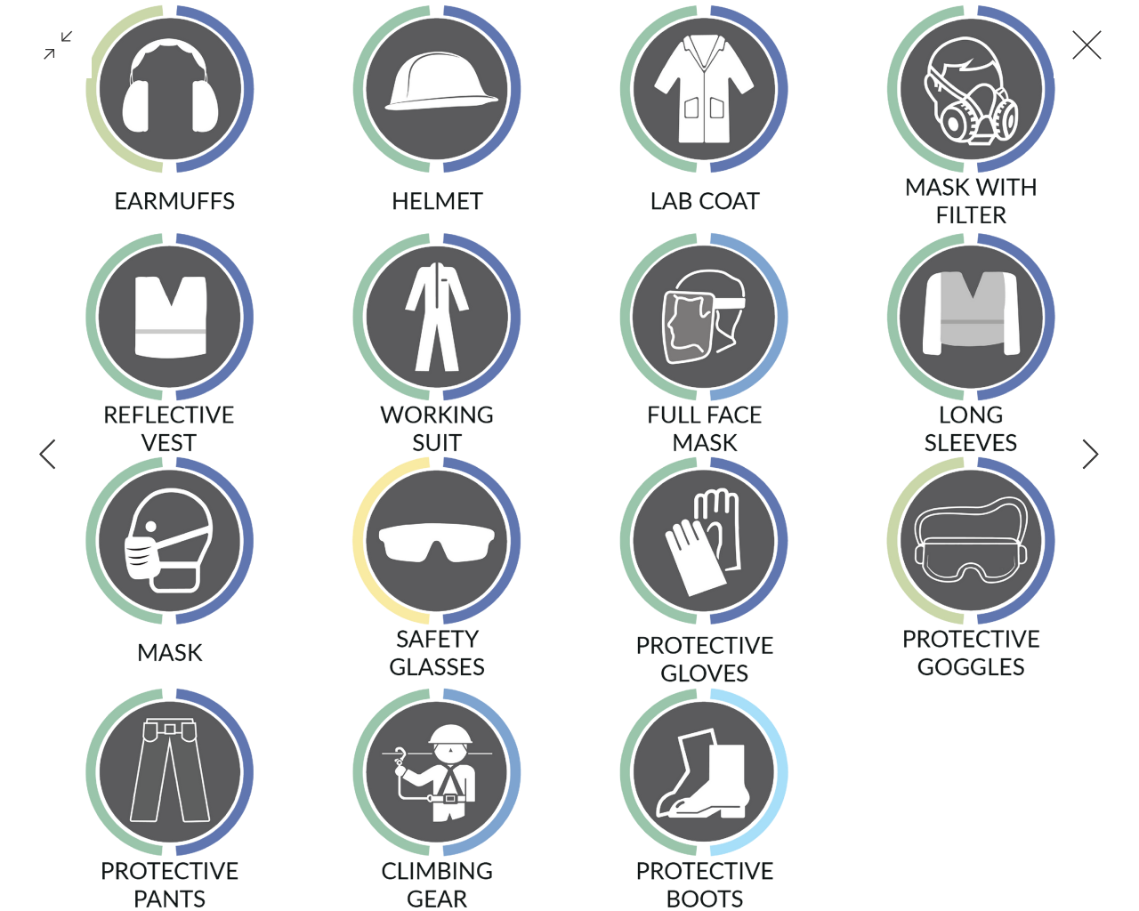

While trains are normally considered safer than other means of transportation, passengers and railway workers on train platforms occasionally encounter deadly risks, such as colliding with a moving train. An unintentional oversight can therefore quickly cause a costly and potentially deadly accident. By using our AI solution, companies can prevent fatal and non-fatal incidents. Our solution uses real-time network data, which can be readily available on-site, to analyze and predict the movement of people and trains that could result in accidents. If the AI detects a worker crossing the railway or a passenger standing too close to a train, it will notify the individual by triggering a light alarm. Additionally, we can create a direct connection to the train and activate the train's horn through the local wireless network, ensuring individuals are alerted and can move a safe distance away. This can also be used inside tunnels to increase the safety of workers by warning them about incoming trains. Additionally, our solutions’ reliability of detection is not impacted by lighting conditions, as we use novel methods for data engineering.

